# Pyspark Project

## Introduction

Pyspark –help

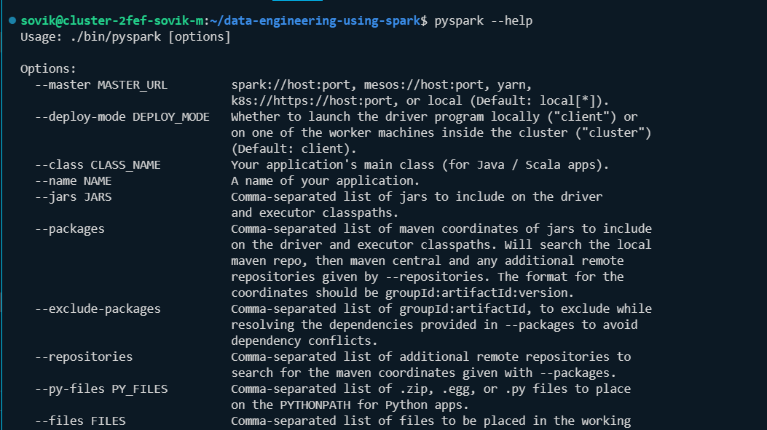

Pyspark

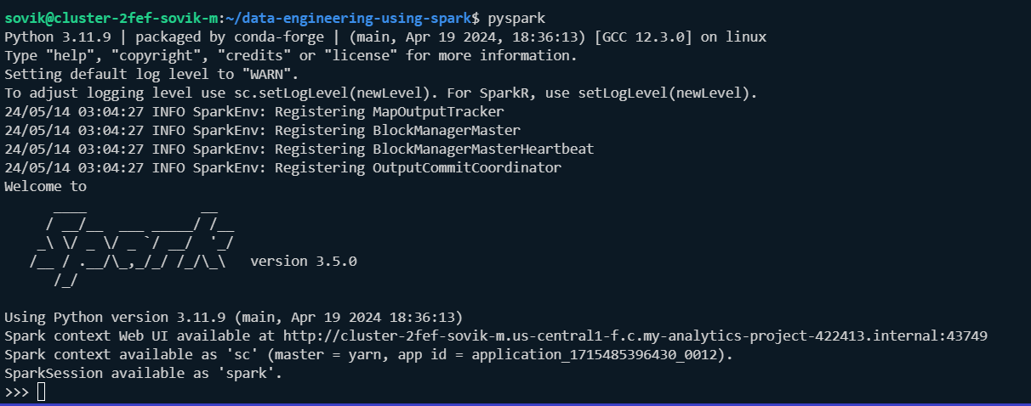

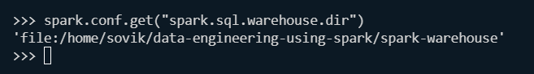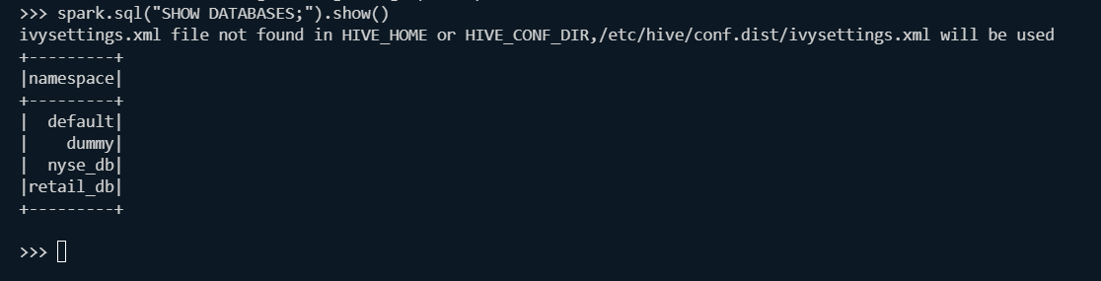

To create we need to launch the pyspark with correct location where we have the privilege of creating database:

pyspark --conf spark.sql.warehouse.dir=/user/`whoami`/spark/warehouse

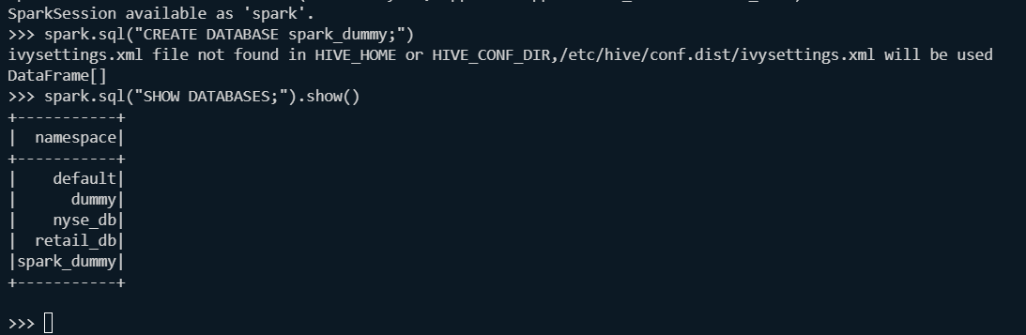

Runtime spark sql warehouse directory;

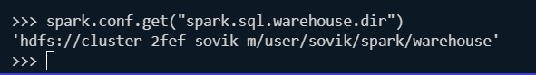

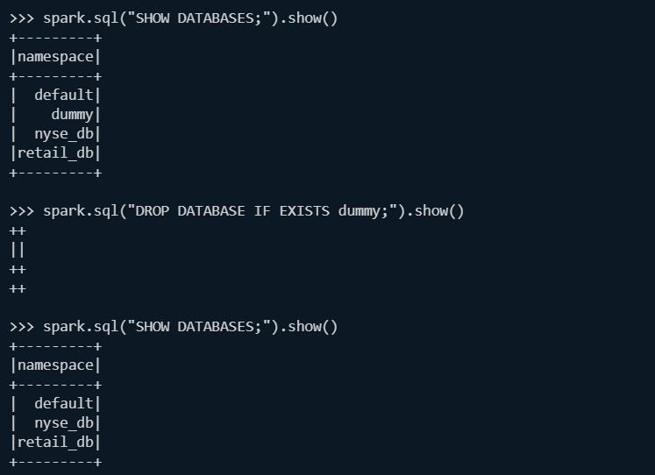

Important spark sql files:

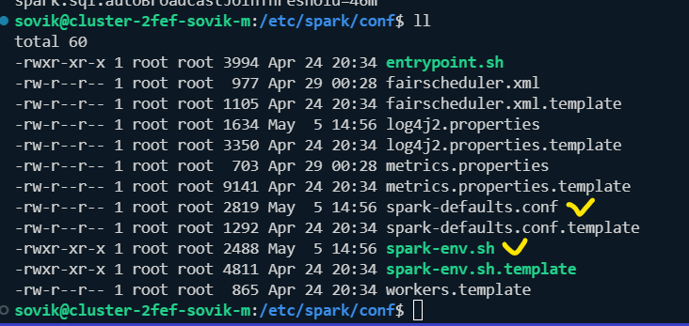

We load the data from local into the hdfs:

hdfs dfs -put /home/sovik/data-engineering-using-spark/data/retail_db /user/sovik/retail_db



Check:

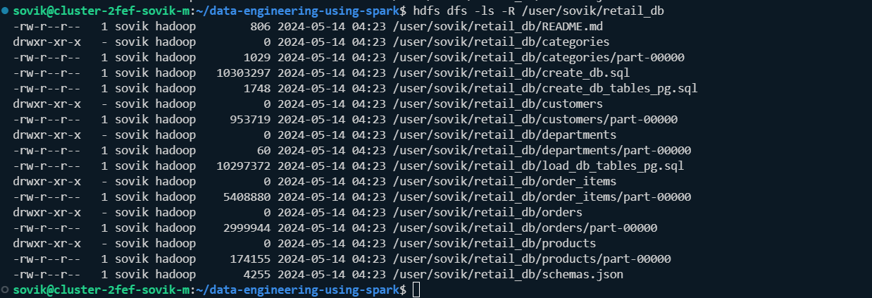

## Getting started with departments example

Login to spark

Show doc about spark.read

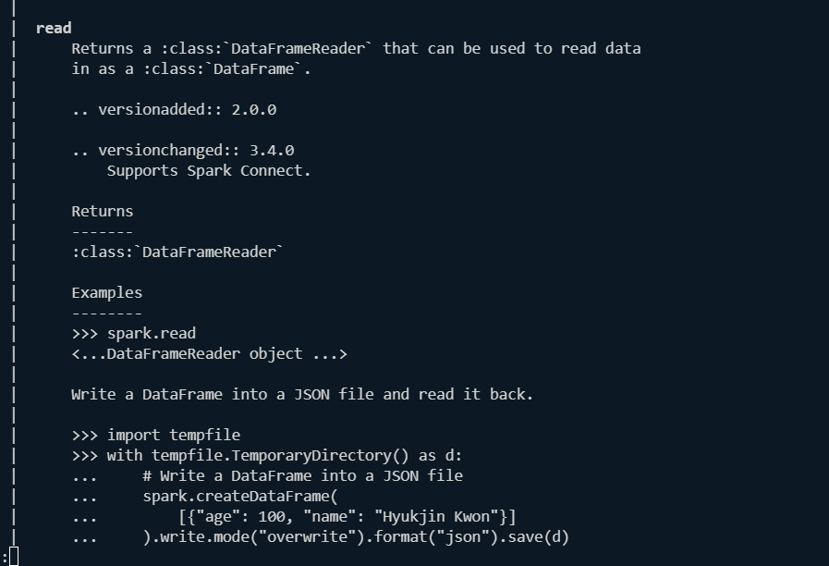

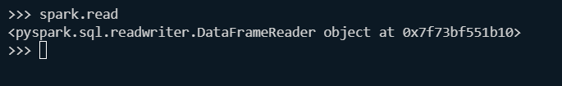

Check the data frames for departments:

spark.read.csv("/user/sovik/retail_db/departments",schema="department_id INT,department_name STRING").show()

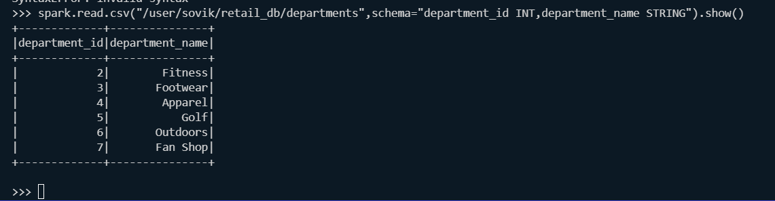

Create department_df:

Department_df= spark.read.csv("/user/sovik/retail_db/departments",schema="department_id INT,department_name STRING")

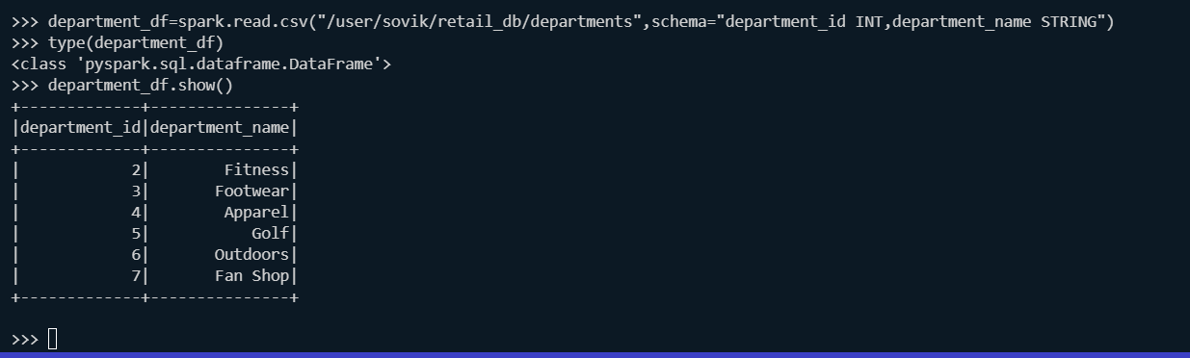 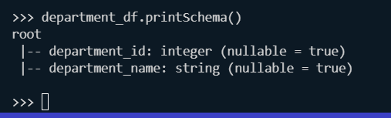

Department_df.<Press 2*tab>

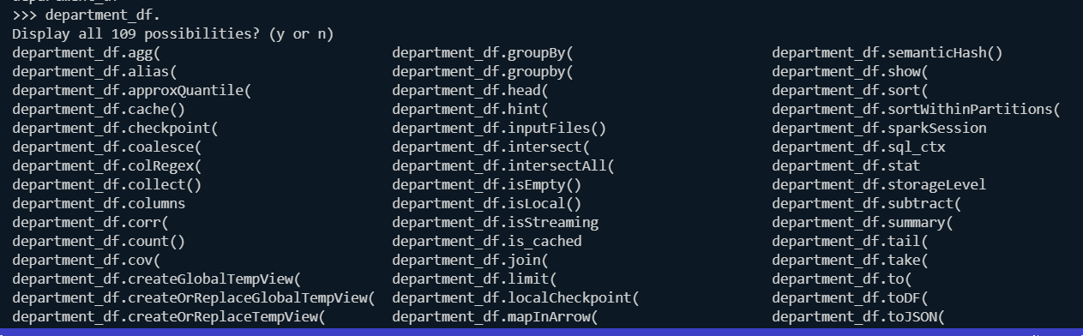

## Create orders and order_items data frame:

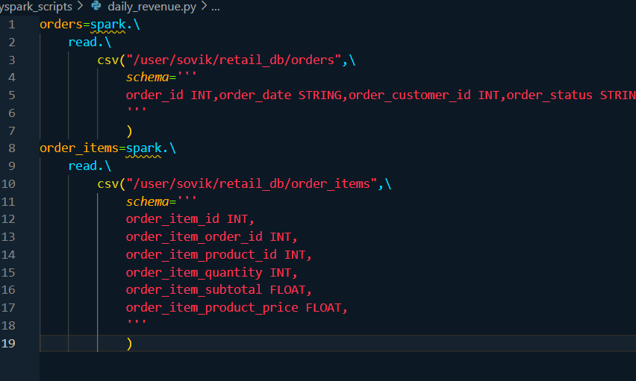

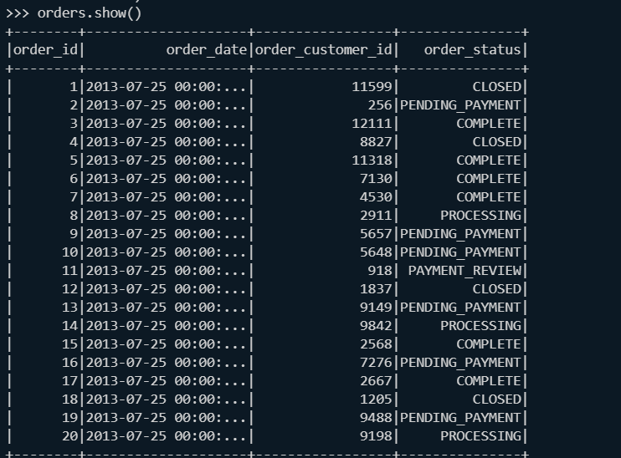

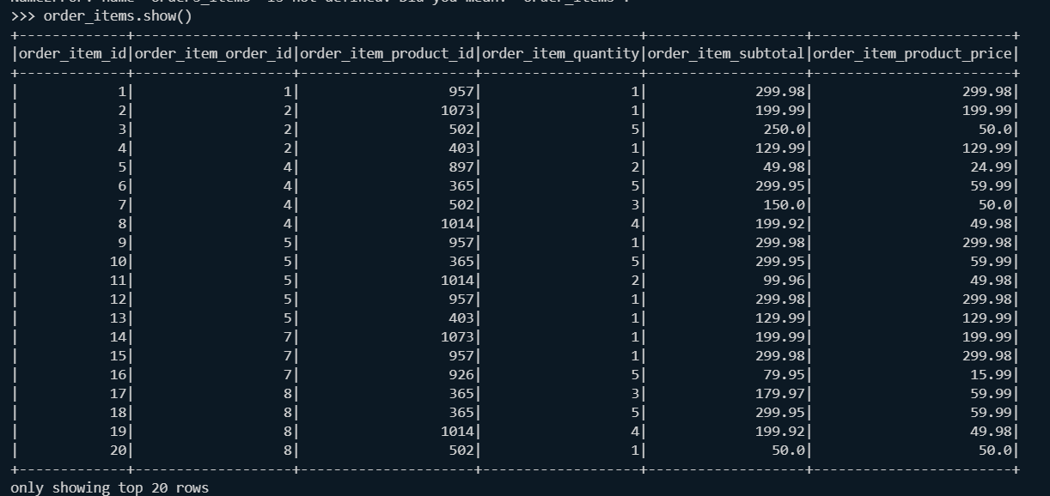

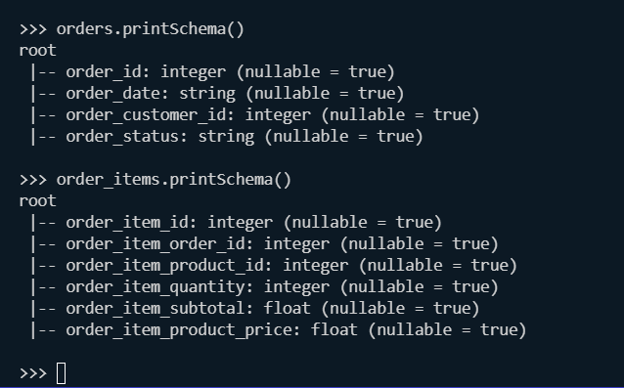

Orders daily:

*from* pyspark.sql.functions *import* sum,round

orders_daily=orders.filter('''order_status IN ('COMPLETE','CLOSED')''').\

    join(order_items,orders['order_id']==order_items['order_item_id']).\

        groupBy('order_date').\

            agg(round(sum('order_item_subtotal'),2).alias('revenue')).\

                orderBy('order_date')

>>> from pyspark.sql.functions import sum,round

>>> orders_daily=orders.filter('''order_status IN ('COMPLETE','CLOSED')''').\

... join(order_items,orders['order_id']==order_items['order_item_id']).\

... groupBy('order_date').\

... agg(round(sum('order_item_subtotal'),2).alias('revenue')).\

... orderBy('order_date')

>>> orders_daily.show(truncate=False)

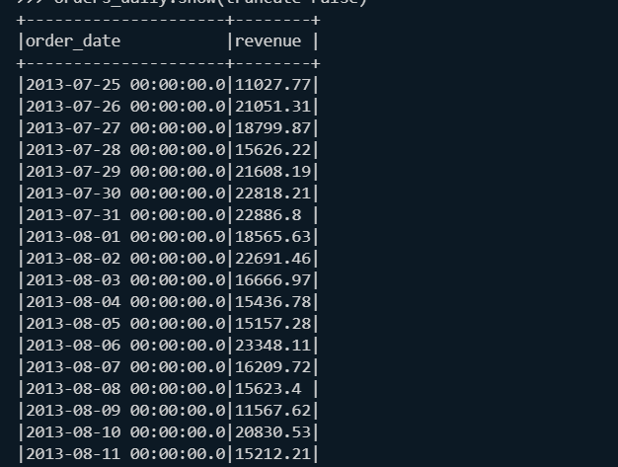

Save it in a location;

orders_daily.\

    toDF('order_date','order_revenue').\

    write.\

        mode('overwrite').\

            csv('/user/sovik/retail_db/daily_revenue')

Verify:

spark.read.csv('/user/sovik/retail_db/daily_revenue').show()

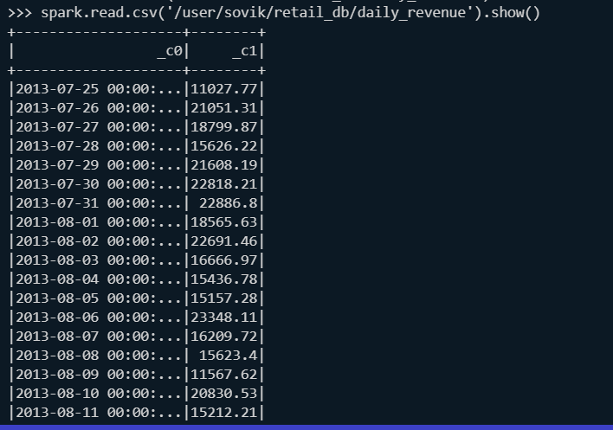

From file system:



## Spark submit

Spark-submit –help

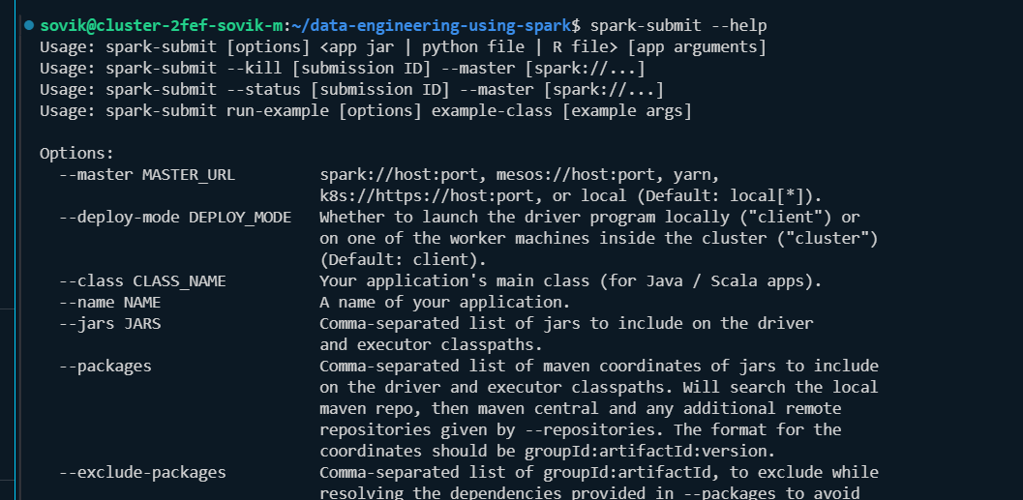

Create the scripts:

One unpartitioned op-version CSV

*from* pyspark.sql *import* SparkSession

*from* pyspark.sql.functions *import* sum, round

*# Initialize Spark Session*

spark = SparkSession. \

    builder. \

    appName('Compute Daily Revenue'). \

    master('yarn'). \

    getOrCreate()

*# Read orders data frame*

orders = spark. \

    read. \

    csv("/user/sovik/retail_db/orders",

*schema*='''

        order_id INT, order_date STRING, order_customer_id INT, order_status STRING

        ''',

*header*=False

    )

*# Read order-items data frame*

order_items = spark. \

    read. \

    csv("/user/sovik/retail_db/order_items",

*schema*='''

        order_item_id INT,

        order_item_order_id INT,

        order_item_product_id INT,

        order_item_quantity INT,

        order_item_subtotal FLOAT,

        order_item_product_price FLOAT

        ''',

*header*=False

    )

*# Filter, join, group and aggregate to get daily revenue*

orders_daily = orders.filter("order_status IN ('COMPLETE', 'CLOSED')"). \

    join(order_items, orders['order_id'] == order_items['order_item_order_id']). \

    groupBy('order_date'). \

    agg(round(sum('order_item_subtotal'), 2).alias('revenue')). \

    orderBy('order_date')

*# Write the result to CSV*

orders_daily. \

    write. \

    mode('overwrite'). \

    csv('/user/sovik/retail_db/daily_revenue')

*# Validate - Display and count rows in the resultant data frame*

orders_daily.show()

print("Total Rows:", orders_daily.count())

2nd is partitioned op version parquet:

*from* pyspark.sql *import* SparkSession

*from* pyspark.sql.functions *import* sum,round

spark = SparkSession. \

            builder. \

            appName("Compute Daily Revenue").\

            .master('yarn').\

            getOrCreate()

*#orders data frame-bronze*

orders=spark.\

    read.\

        csv("/user/sovik/retail_db/orders",\

*schema*='''

            order_id INT,order_date STRING,order_customer_id INT,order_status STRING

            '''

            )

*# Extract order_month and filter orders*

orders = orders.withColumn('order_month', substr(col('order_date'), 1, 7))

*#order-items data frame-bronze*

order_items=spark.\

    read.\

        csv("/user/sovik/retail_db/order_items",\

*schema*='''

            order_item_id INT,

            order_item_order_id INT,

            order_item_product_id INT,

            order_item_quantity INT,

            order_item_subtotal FLOAT,

            order_item_product_price FLOAT

            '''

            )

*#order-daily data-frame silver*

orders_daily=orders.filter('''order_status IN ('COMPLETE','CLOSED')''').\

    join(order_items,orders['order_id']==order_items['order_item_id']).\

        groupBy('order_date').\

            agg(round(sum('order_item_subtotal'),2).alias('revenue')).\

                orderBy('order_date')

*#daily revenue data-frame silver*

daily_revenue_partitioned=orders_daily.\

    toDF('order_date','order_revenue').\

    write.\

        mode('overwrite').\

            partitionBy('order_month').\

            parquet('/user/sovik/retail_db/daily_revenue_parquet')

*#validate*

daily_revenue_partitioned.show()

daily_revenue_partitioned.count()

cleanup:



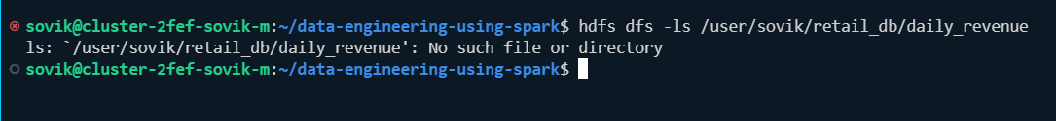

Now we use spark submit:

### Client-mode: For csv output we have the following command(non-partitioned ):

spark-submit /home/sovik/data-engineering-using-spark/pyspark_scripts/daily_revenue_computation_final.py

O/P: Validation:

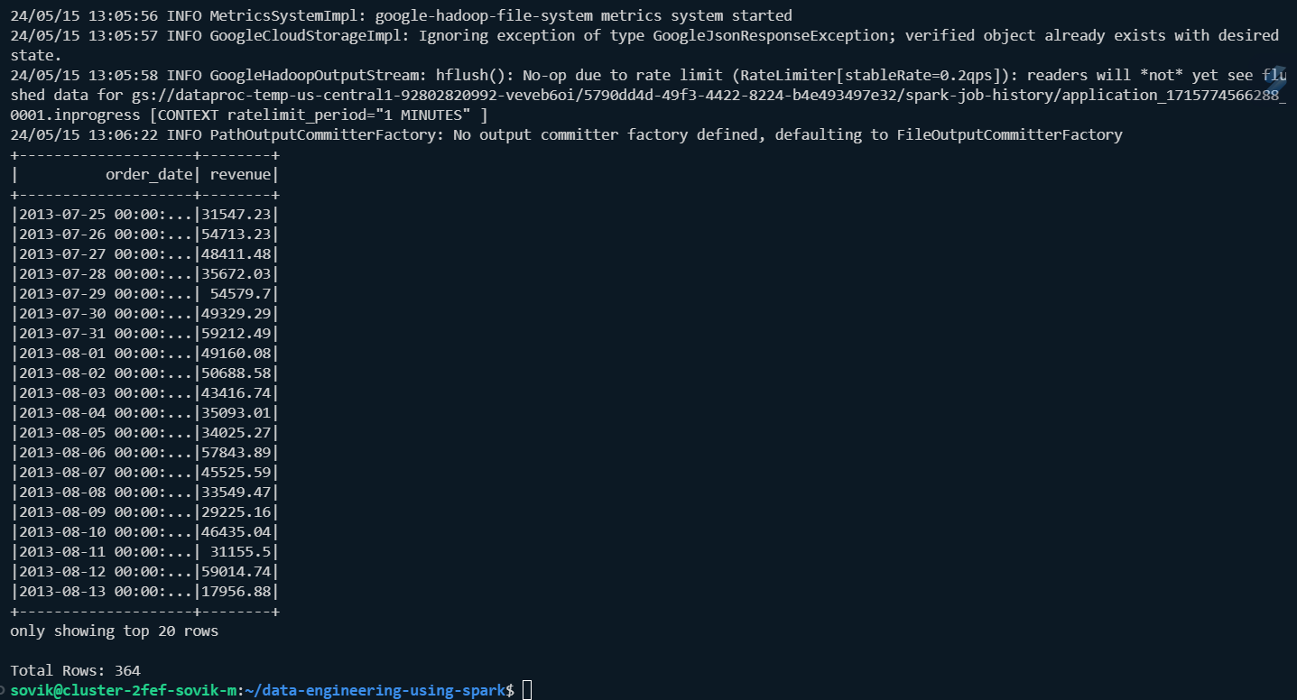

### Cluster-mode: For csv output we have the following command(non-partitioned ):

Cleanup:

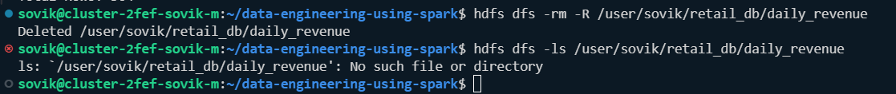

Command:

spark-submit --deploy-mode cluster /home/sovik/data-engineering-using-spark/pyspark_scripts/daily_revenue_computation_final.py

O/P: 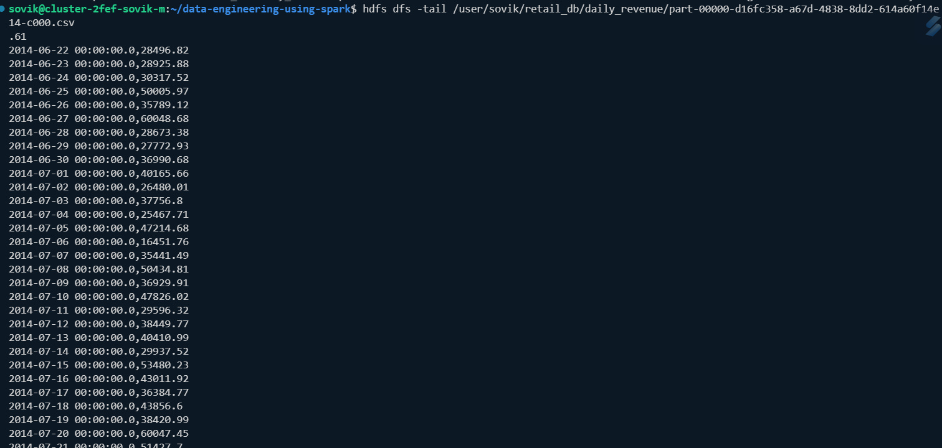

## Create Environment Variable

Cleanup

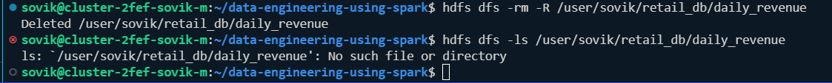

Provide environment variable:



Note: in my case both are same

Deployin client mode:(non-partitioned):

**spark-submit --deploy-mode client /home/sovik/data-engineering-using-spark/pyspark_scripts/daily_revenue_computation_final.py**

output:

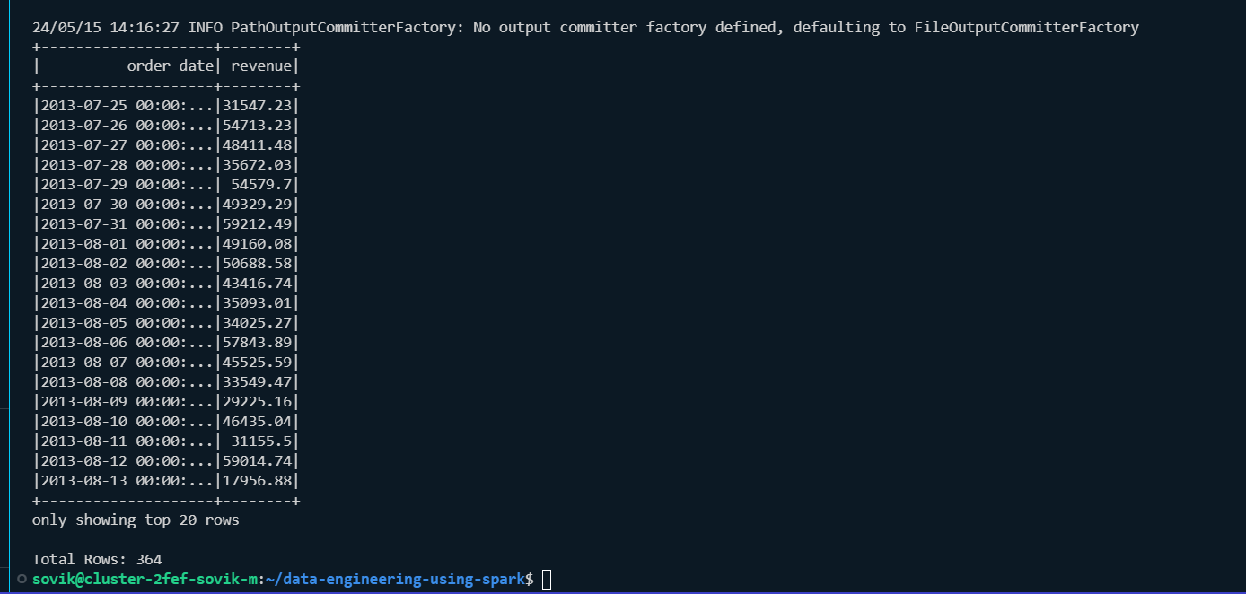

Validate file:



Deploy in cluster mode:(non-partitioned):

Cleanup:

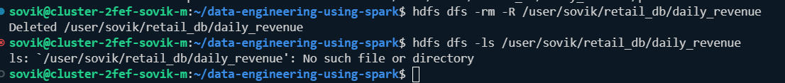

**spark-submit --deploy-mode cluster /home/sovik/data-engineering-using-spark/pyspark_scripts/daily_revenue_computation_final.py**

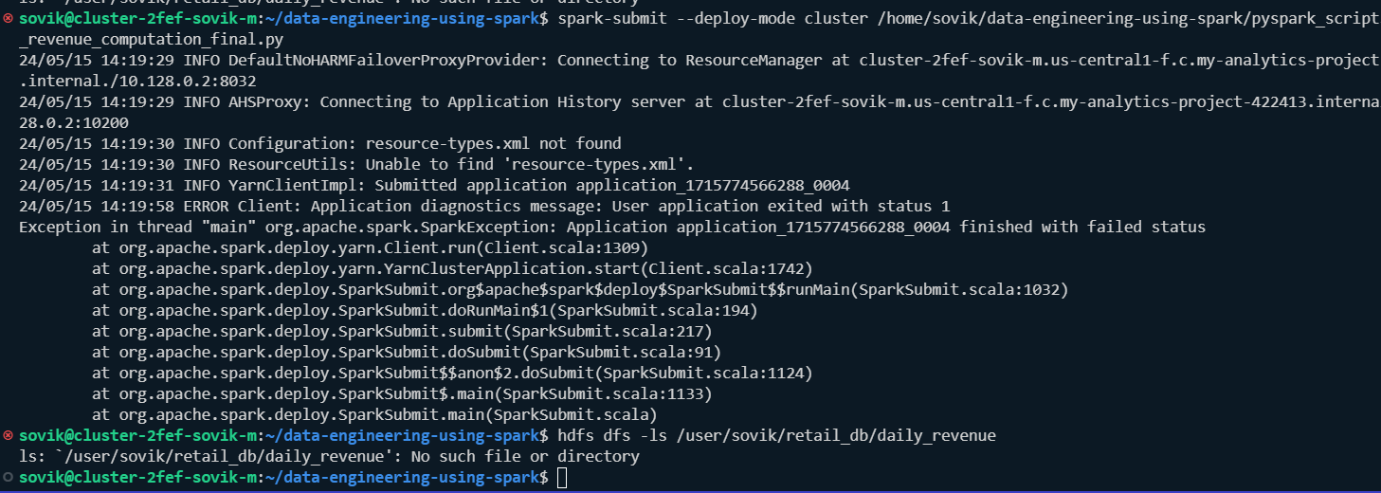

**We get this error lets check the environment variables:**

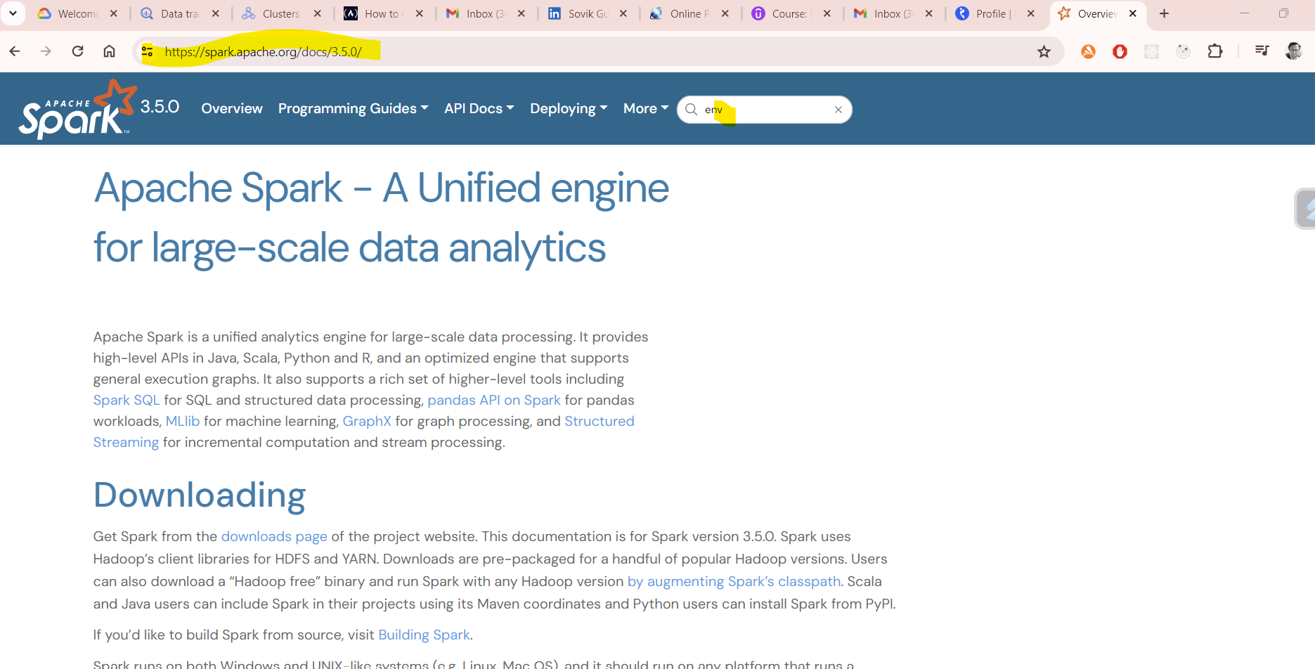

Note: When running Spark on YARN in cluster mode, environment variables need to be set using the spark.yarn.appMasterEnv.[EnvironmentVariableName] property in your conf/spark-defaults.conf file. Environment variables that are set in spark-env.sh will not be reflected in the YARN Application Master process in cluster mode. See the [YARN-related Spark Properties](https://spark.apache.org/docs/3.5.0/running-on-yarn.html#spark-properties) for more information.

Our renewed command is:

**spark-submit --deploy-mode cluster --conf spark.yarn.appMasterEnv.SRC_BASE_DIR=/user/sovik/retail**

**_db --conf spark.yarn.appMasterEnv.TGT_BASE_DIR=/user/sovik/retail_db /home/sovik/data-engineering-using-spark/pyspark_scripts/daily_revenue_computation_fin**

**al.py**

**Validated:**

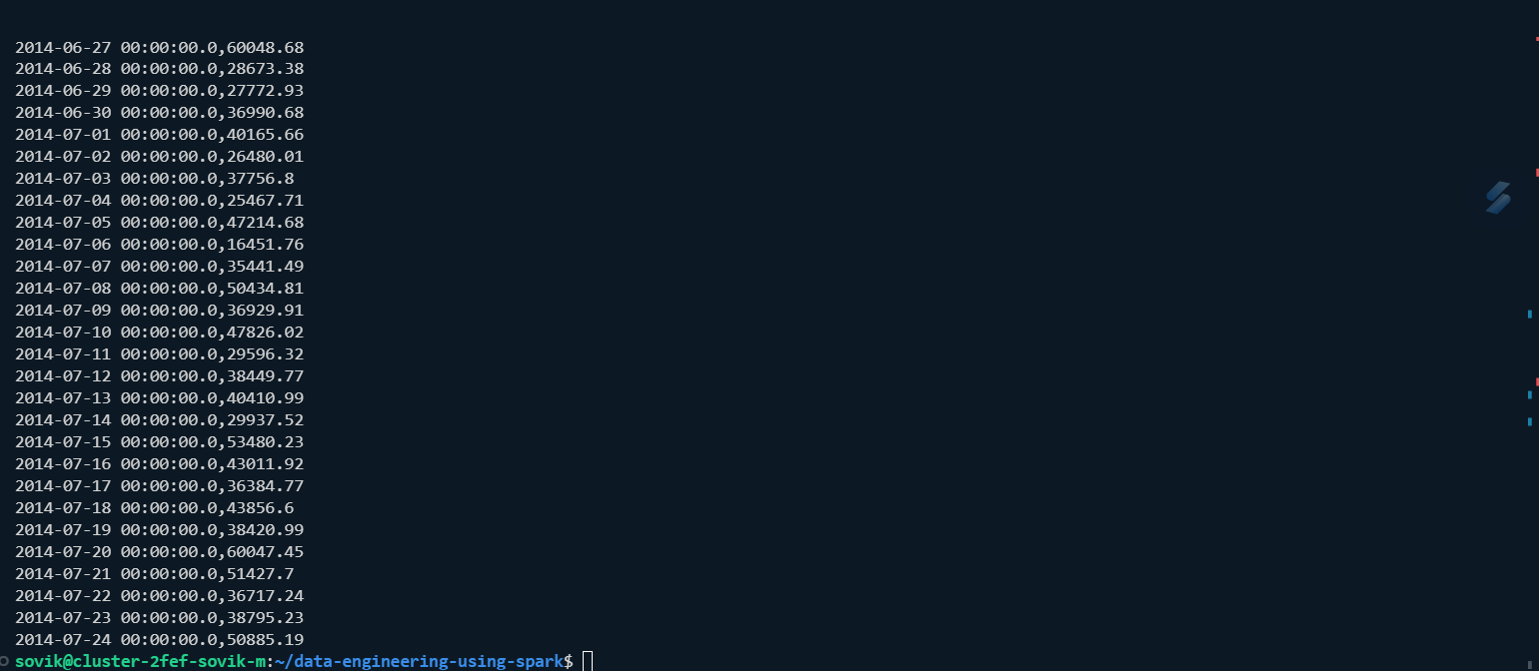

## See the details in web interface:

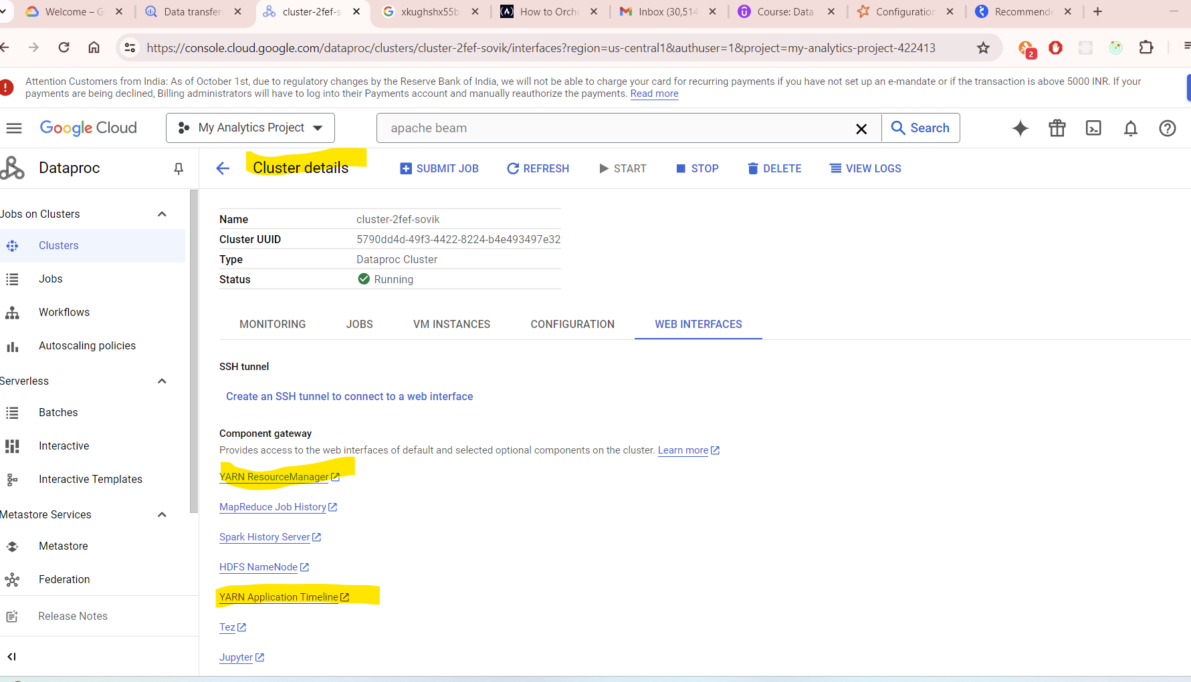

Yarn resource manager:

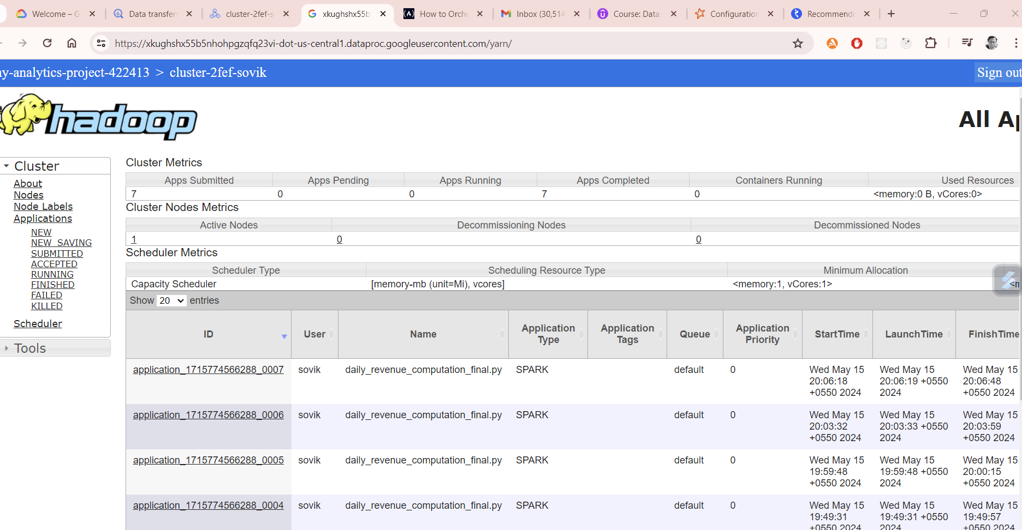

Nodes:

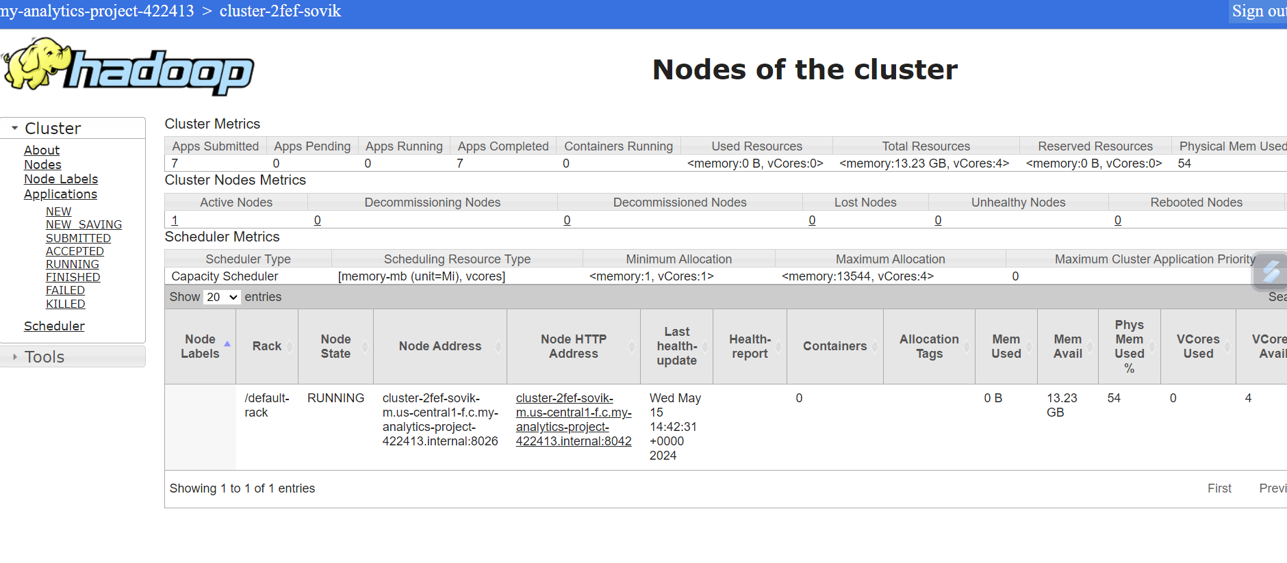

Apps completed:

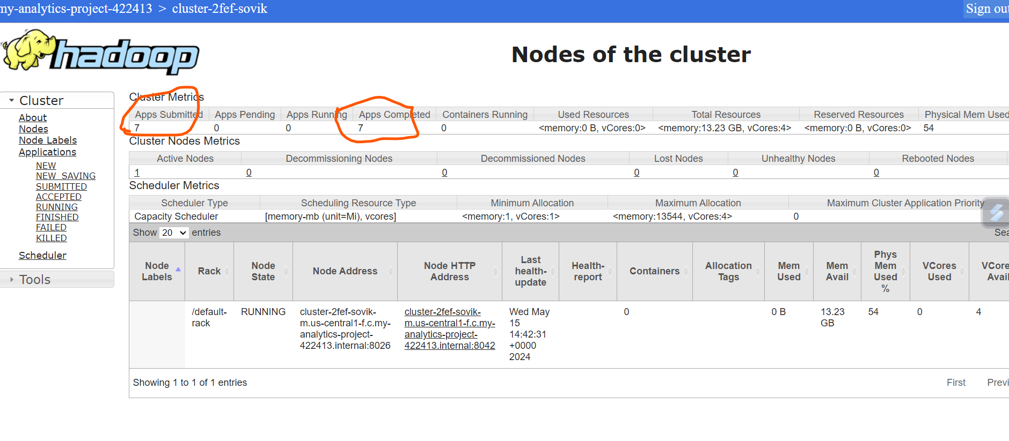

See from console for the last cluster run

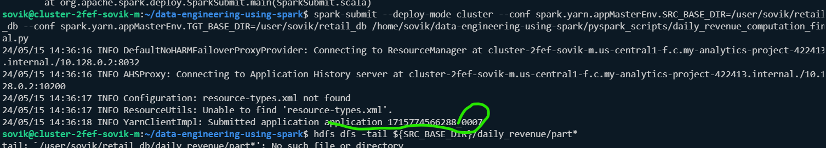

Spark history server:

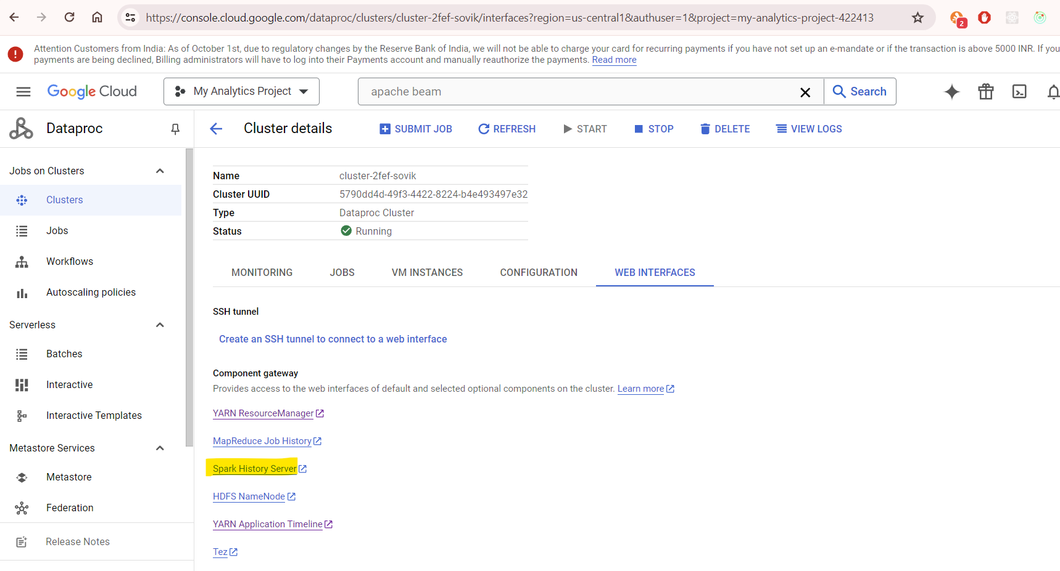

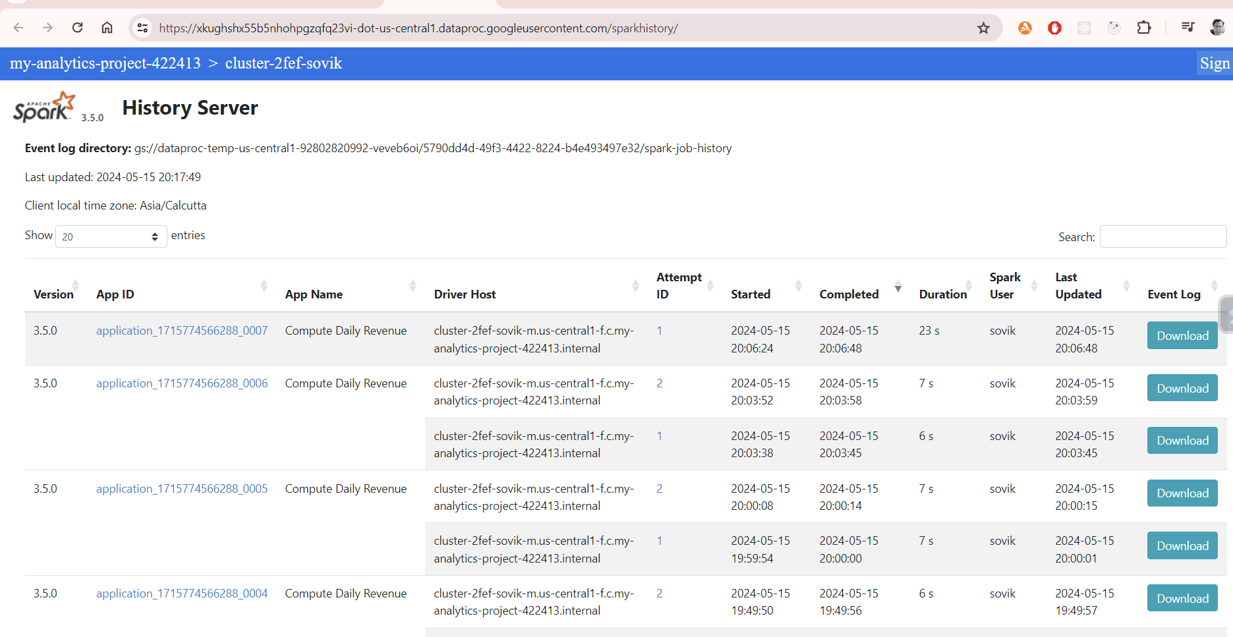

Select a latest job:

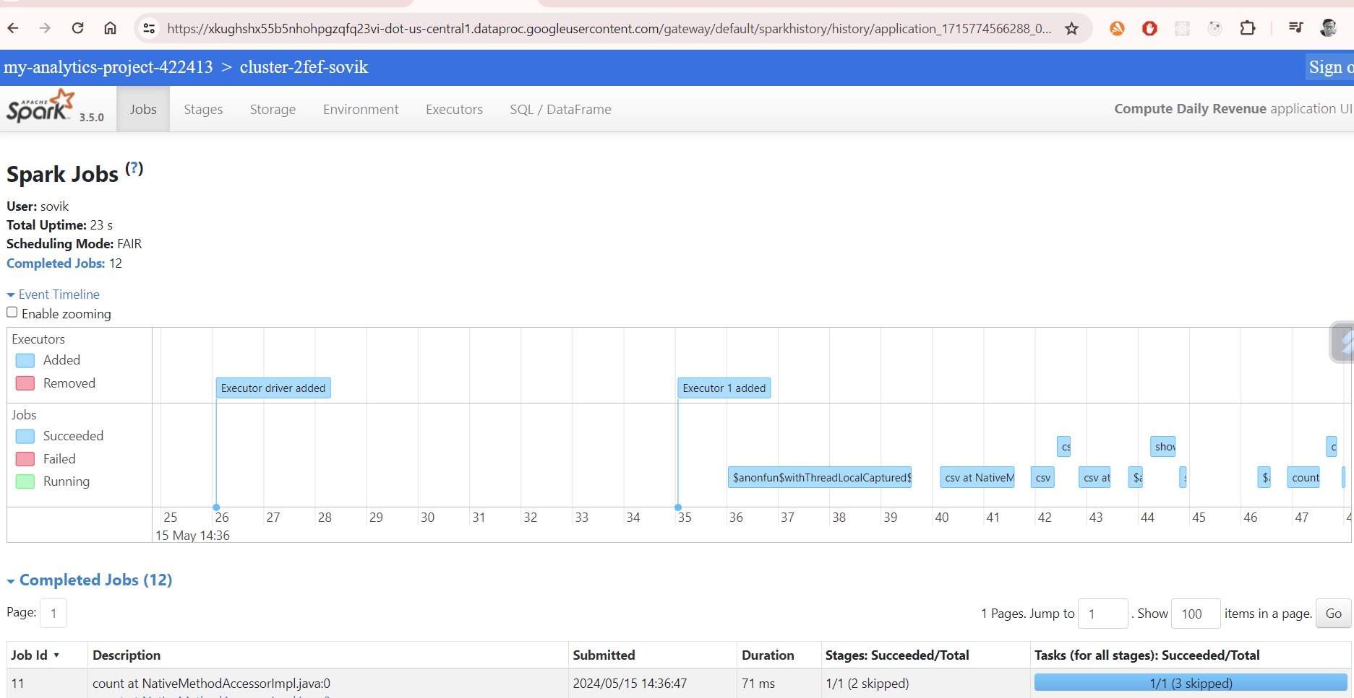

On Properties:deploy mode:

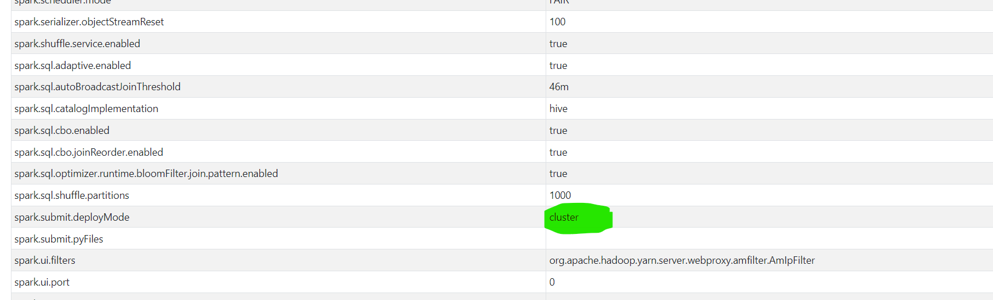

YARN logs:

From Cluster Details-> Web interfaces->

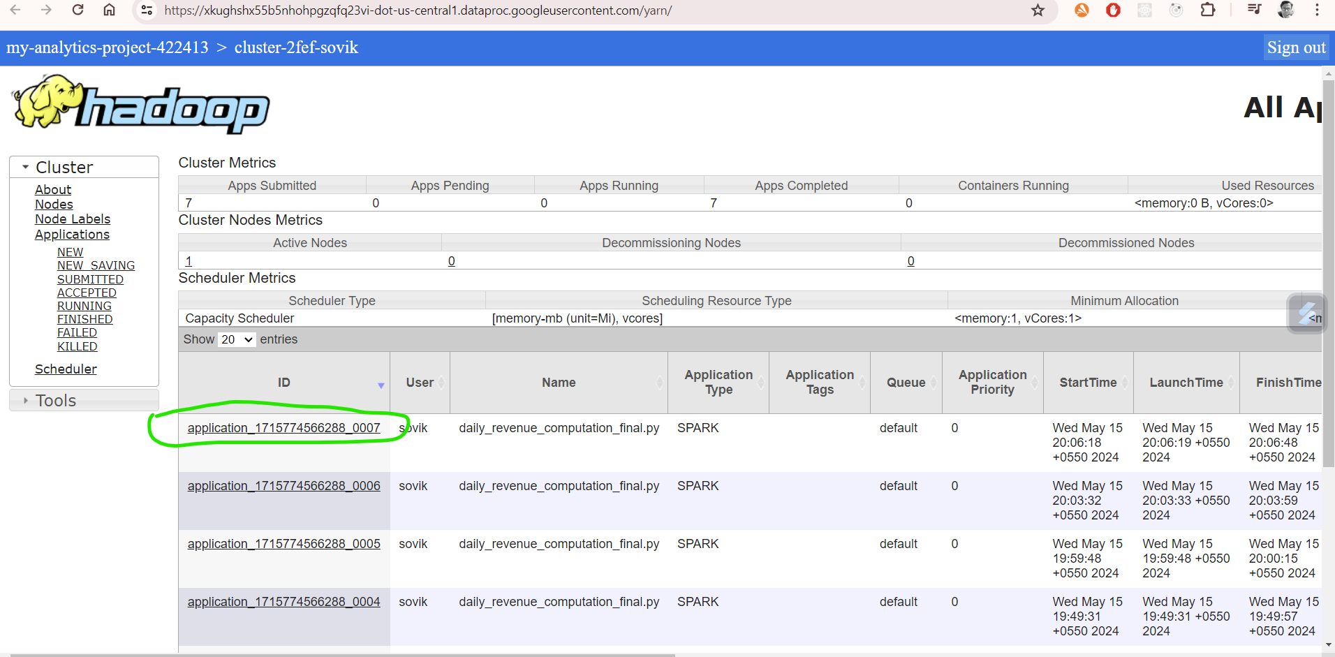

Attempt:

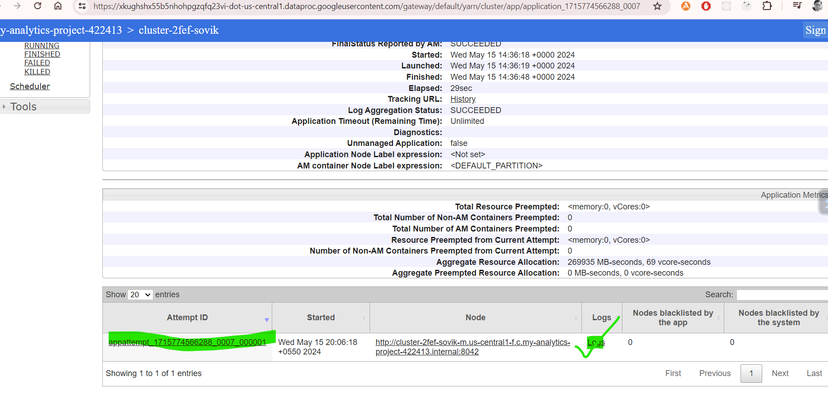

Logs for an app run attempt:

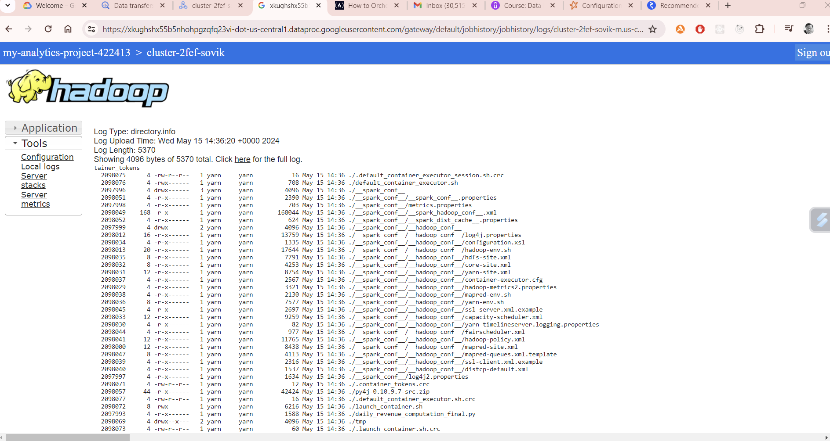

Lets Digress the code which is executed in the Driver and which is executed in the Executers:

Driver till SparkSession Object is created:

Eg:

*import* os

*from* pyspark.sql *import* SparkSession

*from* pyspark.sql.functions *import* sum, round

*# initialize the environmnet variables*

*#SRC_BASE_DIR=/user/sovik/retail_db*

src_base_dir=os.environ.get('SRC_BASE_DIR')

tgt_base_dir=os.environ.get('TGT_BASE_DIR')

*# Initialize Spark Session*

spark = SparkSession. \

    builder. \

    appName('Compute Daily Revenue'). \

    master('yarn'). \

    getOrCreate()

Executer:

*# Initialize Spark Session*

spark = SparkSession. \

    builder. \

    appName('Compute Daily Revenue'). \

    master('yarn'). \

    getOrCreate()

*# Read orders data frame*

orders = spark. \

    read. \

    csv(f"{src_base_dir}/orders",

*schema*='''

        order_id INT, order_date STRING, order_customer_id INT, order_status STRING

        ''',

*header*=False

    )

*# Read order-items data frame*

order_items = spark. \

    read. \

    csv(f"{src_base_dir}/order_items",

*schema*='''

        order_item_id INT,

        order_item_order_id INT,

        order_item_product_id INT,

        order_item_quantity INT,

        order_item_subtotal FLOAT,

        order_item_product_price FLOAT

        ''',

*header*=False

    )

*# Filter, join, group and aggregate to get daily revenue*

orders_daily = orders.filter("order_status IN ('COMPLETE', 'CLOSED')"). \

    join(order_items, orders['order_id'] == order_items['order_item_order_id']). \

    groupBy('order_date'). \

    agg(round(sum('order_item_subtotal'), 2).alias('revenue')). \

    orderBy('order_date')

*# Write the result to CSV*

orders_daily. \

    write. \

    mode('overwrite'). \

    csv(f'{tgt_base_dir}/daily_revenue')

*# Validate - Display and count rows in the resultant data frame*

orders_daily.show()

print("Total Rows:", orders_daily.count())

Difference between cluster mode and client mode:

In client mode the The Driver will run on Client Gateway but the business logic will run on executer:

In cluster mode the driver and the business logic will run on executer.

***For issue with cluster if there is any issue the Issue can be seen in Yarn cluster timeline not Yarn Node Manager***

## Spark submit with Delta partitioned by ordermonth

Change in code for delta partitioning

orders_daily. \

    write. \

    mode('overwrite'). \

    format('delta'). \

    save(f'{tgt_base_dir}/daily_revenue',*header*=True)

cleanup:

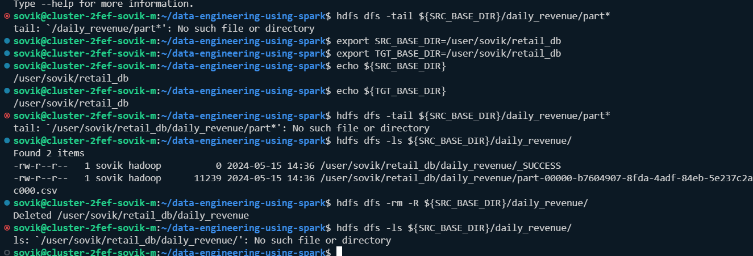

**Command:**

spark-submit \

--deploy-mode cluster \

--packages io.delta:delta-spark_2.12:3.0.0 \

--conf spark.yarn.appMasterEnv.SRC_BASE_DIR=/user/sovik/retail_db \

--conf spark.yarn.appMasterEnv.TGT_BASE_DIR=/user/sovik/retail_db \

--conf spark.sql.extensions=io.delta.sql.DeltaSparkSessionExtension \

--conf spark.sql.catalog.spark_catalog=org.apache.spark.sql.delta.catalog.DeltaCatalog \

/home/sovik/data-engineering-using-spark/pyspark_scripts/daily_revenue_computation_final.py

Validate:

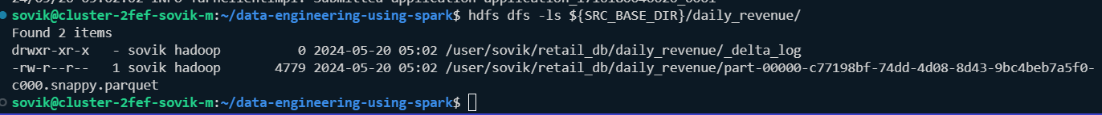

Check the app log in spark in dataproc cluster: Webinstance->YARN Resource Manager

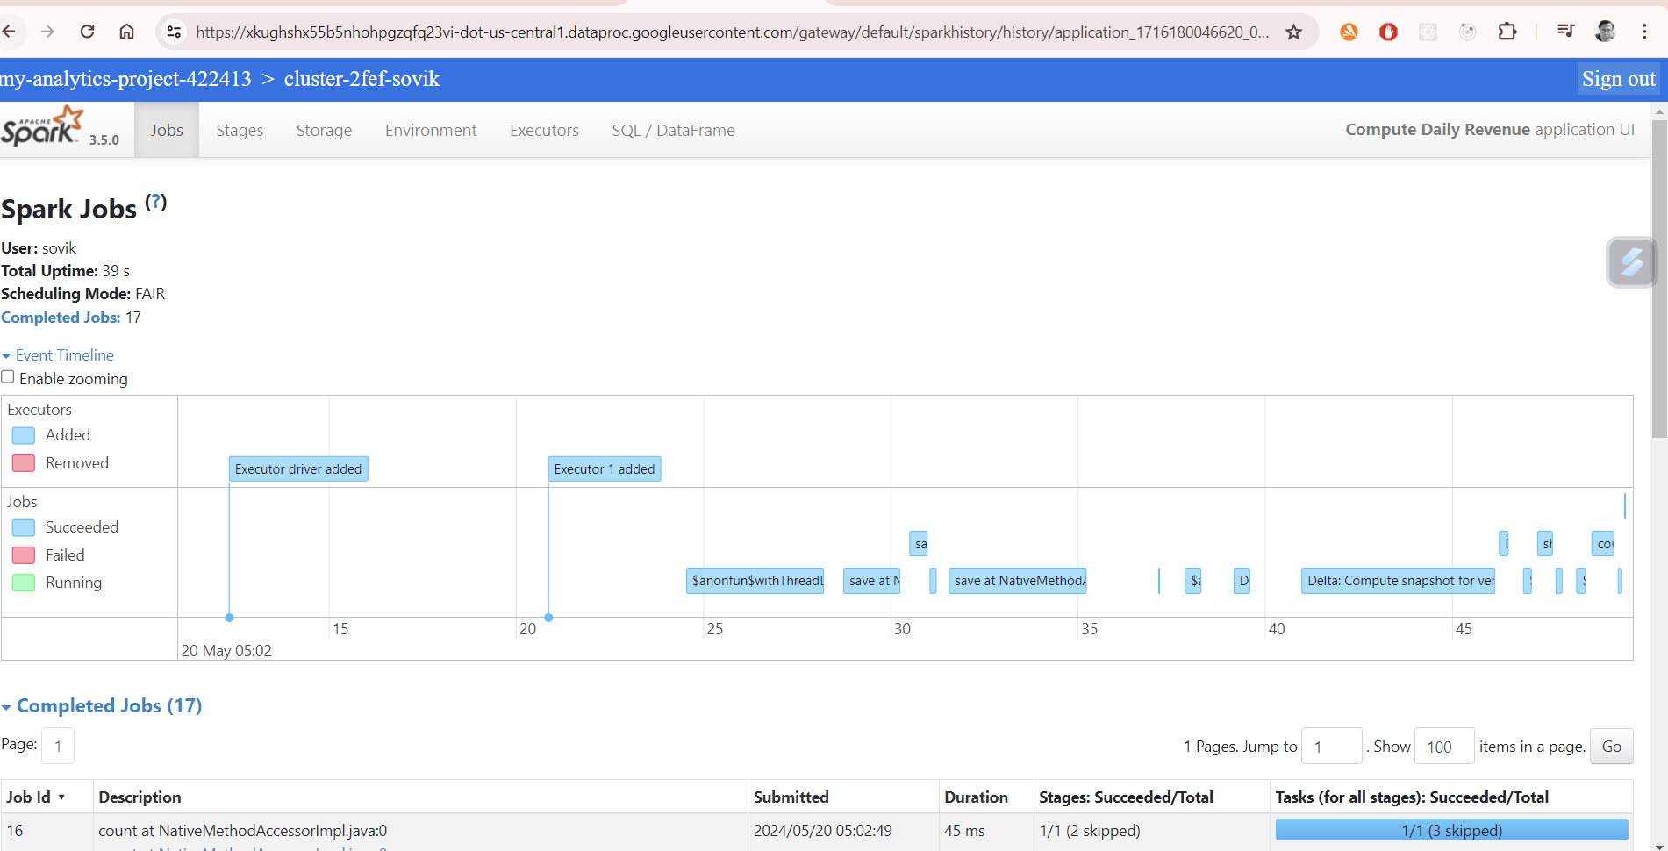

Validate via code:

pyspark --packages io.delta:delta-spark_2.12:3.0.0 \

> --conf spark.sql.extensions=io.delta.sql.DeltaSparkSessionExtension \

> --conf spark.sql.catalog.spark_catalog=org.apache.spark.sql.delta.catalog.DeltaCatalog

o/P:

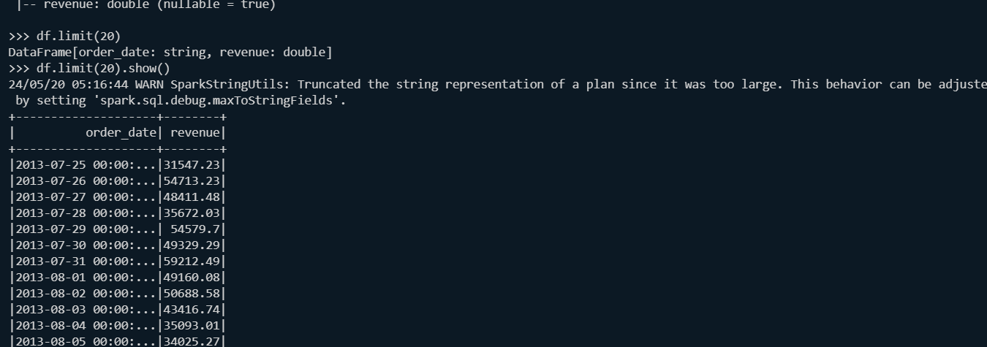

**Lets download the jar files rather that calling it independently all the time:**

io.delta:delta-spark_2.12:3.0.0

Copy the jar link: <https://github.com/delta-io/delta/releases>

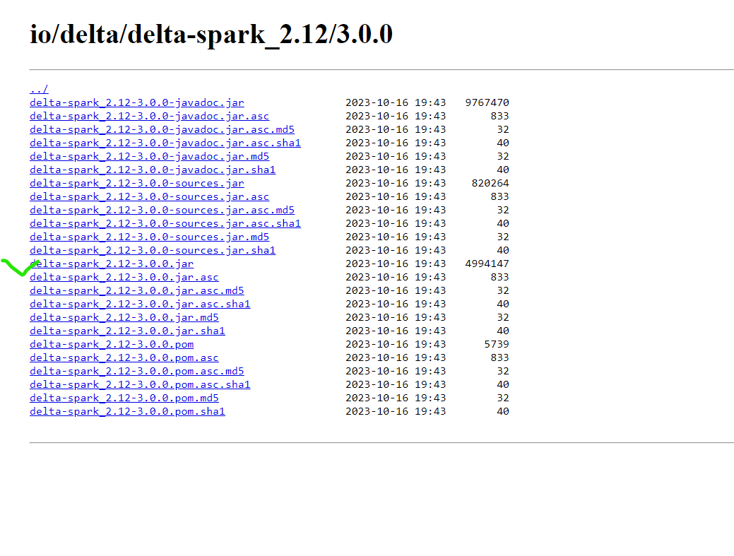

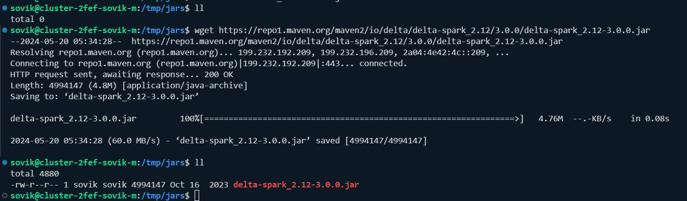

Along with the above we need both the question marked jars as well:

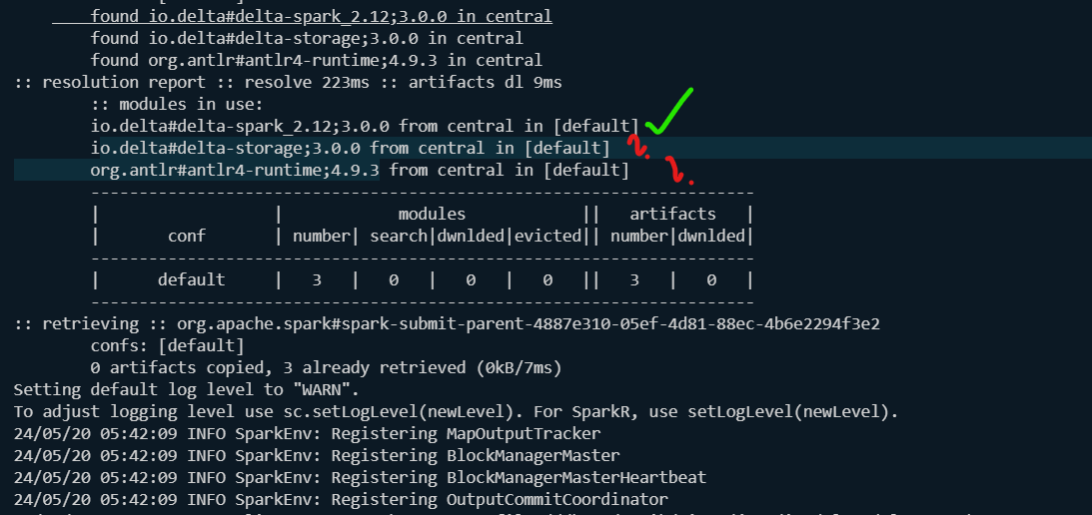

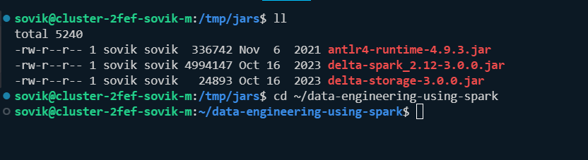

Command run:

spark-submit --deploy-mode cluster \

--conf spark.yarn.appMasterEnv.SRC_BASE_DIR=/user/sovik/retail_db \

--conf spark.yarn.appMasterEnv.TGT_BASE_DIR=/user/sovik/retail_db \

--jars /tmp/jars/antlr4-runtime-4.9.3.jar,/tmp/jars/delta-storage-3.0.0.jar,/tmp/jars/delta-spark_2.12-3.0.0.jar \

--conf spark.sql.extensions=io.delta.sql.DeltaSparkSessionExtension \

--conf spark.sql.catalog.spark_catalog=org.apache.spark.sql.delta.catalog.DeltaCatalog \

/home/sovik/data-engineering-using-spark/pyspark_scripts/daily_revenue_computation_final.py

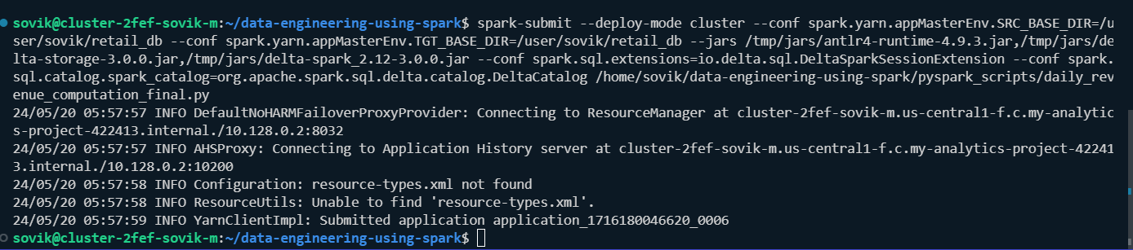

Validate:

*Same as previous validation:*

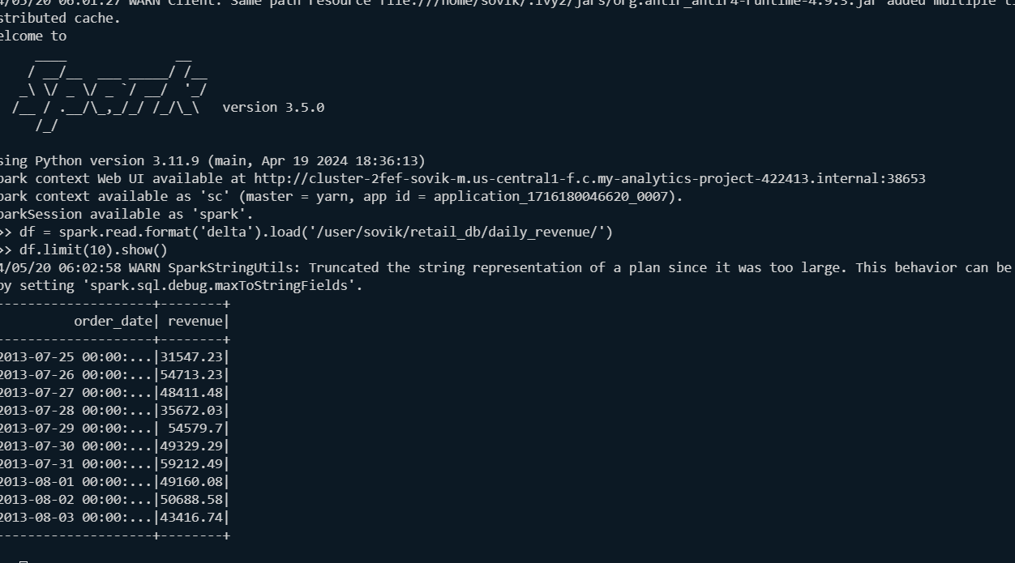

Create a shell wrapper with command as below->give permission chmod 777 -run:

spark-submit --deploy-mode cluster \

--conf spark.yarn.appMasterEnv.SRC_BASE_DIR=/user/sovik/retail_db \

--conf spark.yarn.appMasterEnv.TGT_BASE_DIR=/user/sovik/retail_db \

--jars /tmp/jars/antlr4-runtime-4.9.3.jar,/tmp/jars/delta-storage-3.0.0.jar,/tmp/jars/delta-spark_2.12-3.0.0.jar \

--conf spark.sql.extensions=io.delta.sql.DeltaSparkSessionExtension \

--conf spark.sql.catalog.spark_catalog=org.apache.spark.sql.delta.catalog.DeltaCatalog \

/home/sovik/data-engineering-using-spark/pyspark_scripts/daily_revenue_computation_final.py